VGA Cable Pinouts

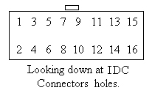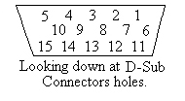

15 Pin HD VGA
19 Pin IDC Connector - Female D-Sub Connector – Female

1 ---------------BLUE-------------- 3
2 -----------Monitor ID 2---------- 4
3 --------------GREEN------------- 2
4 ------GREEN GROUND------- 7
5 ----------------RED--------------- 1
6 ---------RED GROUND-------- 6
9-------------GROUND------------5
10-------------H-SYNC-------------13
11-----------Monitor ID 0----------11
12 ------------V-SYNC------------ 14

RGB Cable Pinouts
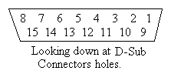

15 Pin RGB
19 Pin IDC Connector - Female D-Sub Connector – Female

1 ------------------------------------- 1
2 ------------------------------------- 9
3 ------------------------------------- 2
4 ------------------------------------ 10
5 ------------------------------------- 3
6 ------------------------------------ 11
7 ------------------------------------- 4
8 ------------------------------------ 12
9 ------------------------------------- 5
10 ------------------------------------ 13
11 ------------------------------------- 6
12 ------------------------------------ 14
13 ------------------------------------- 7
14 ------------------------------------ 15
15 ------------------------------------- 8

Note: A 15 Pin RGB Crimp (IDC) connector should be used for the RGB Cable. Just crimp the Ribbon Cable oriented to Pin 1 on each connector.

