A transistor inverter (NOT gate)
Inverters (NOT gates) are available on logic ICs but if you only require one inverter it is usually better to use this circuit. The output signal (voltage) is the inverse of the input signal:
- When the input is high (+Vs) the output is low (0V).
- When the input is low (0V) the output is high (+Vs).
Any general purpose low power NPN transistor can be used. For general use R_{B} = 10k and R_{C} = 1k, then the inverter output can be connected to a device with an input impedance (resistance) of at least 10k such as a logic IC or a 555 timer (trigger and reset inputs).
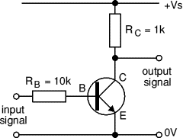
If you are connecting the inverter to a CMOS logic IC input (very high impedance) you can increase R_{B} to 100k and R_{C} to 10k, this will reduce the current used by the inverter.

Choosing a suitable PNP transistor
The circuit diagram shows how to connect a PNP transistor, this will switch on the load when the IC output is low (0V). If you need the opposite action, with the load switched on when the IC output is high please see the circuit for an NPN transistor above.
The procedure for choosing a suitable PNP transistor is exactly the same as that for an NPN transistor described above.
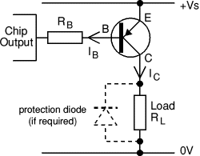
PNP transistor switch
(load is on when IC output is low)

